DirectX+CEGUI 窗口显示

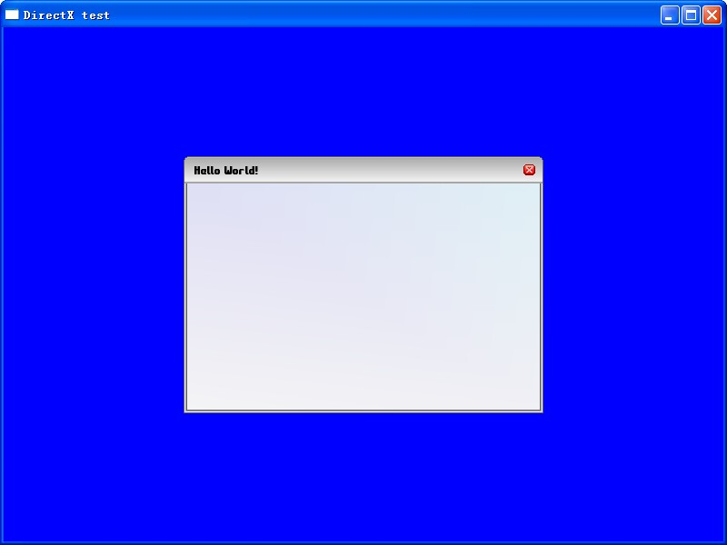
首先设置好资源路径之后得调用
CEGUI::SchemeManager::getSingleton().loadScheme( "WindowsLook.scheme" );
不调用这个那么创建会失败，当然WindowsLook只是众多窗口样式的一种。
我说下基本的dll debug模式下 若用D3D 至少需要下面几个dll CEGUIBase_d,dll CEGUIExpatParser_d.dll,DirectX9GUIRenderer_d.dll,CEGUIFalagardWRBase_d.dll,
整体源代码如下：当然只是为了测试，代码有点撇，大家都能看懂。
#include <d3d9.h>
#include "CEGUI.h"
#include "directx9GUIRenderer\\d3d9renderer.h"
#include "CEGUIDefaultResourceProvider.h"
#pragma comment(lib,"CEGUIBase_d.lib")
#pragma comment(lib,"DirectX9GUIRenderer_d.lib")
using namespace CEGUI;
LPDIRECT3D9 g_pD3d = NULL;
LPDIRECT3DDEVICE9 g_pD3dDevice = NULL;
LPDIRECT3DVERTEXBUFFER9 g_pVB = NULL;
DirectX9Renderer* myRenderer = NULL;
CEGUI::DefaultResourceProvider* rp = NULL;
struct CUSTOMVERTEX
{
float x,y,z,rhw;
DWORD color;
};
#define D3DFVF_CUSTOMVERTEX (D3DFVF_XYZRHW | D3DFVF_DIFFUSE)
HRESULT InitD3d(HWND hWnd)
{
if (NULL == (g_pD3d = Direct3DCreate9(D3D_SDK_VERSION)))
{
return E_FAIL;
}
D3DPRESENT_PARAMETERS d3dpp;
ZeroMemory(&d3dpp,sizeof(d3dpp));
d3dpp.Windowed = TRUE;
d3dpp.SwapEffect = D3DSWAPEFFECT_DISCARD;
d3dpp.BackBufferFormat = D3DFMT_UNKNOWN;
if (FAILED(g_pD3d->CreateDevice(D3DADAPTER_DEFAULT,D3DDEVTYPE_HAL,
hWnd,D3DCREATE_SOFTWARE_VERTEXPROCESSING,
&d3dpp,&g_pD3dDevice)))
{
return E_FAIL;
}
return S_OK;
}
void Cleanup()
{
if (g_pD3dDevice != NULL)
{
g_pD3dDevice->Release();
}
if (g_pD3d != NULL)
{
g_pD3d->Release();
}
}
void Render()
{
if (NULL == g_pD3dDevice)
{
return;
}
if (SUCCEEDED(g_pD3dDevice->BeginScene()))
{
g_pD3dDevice->Clear(0,NULL,D3DCLEAR_TARGET,D3DCOLOR_XRGB(0,0,255),
1.0f,0);
CEGUI::System::getSingleton().renderGUI();
g_pD3dDevice->EndScene();
}
g_pD3dDevice->Present(NULL,NULL,NULL,NULL);
}
LRESULT WINAPI MsgProc(HWND hWnd,UINT msg,WPARAM wParam,LPARAM lParam)
{
switch(msg)
{
case WM_DESTROY:
Cleanup();
PostQuitMessage(0);
return 0;
}
return DefWindowProc(hWnd,msg,wParam,lParam);
}
INT WINAPI WinMain(HINSTANCE hInst,HINSTANCE,LPSTR,INT)
{
WNDCLASSEX wc ={sizeof(WNDCLASSEX),CS_CLASSDC,MsgProc,0L,0L,
GetModuleHandle(NULL),NULL,NULL,NULL,NULL,
"DirectX",NULL};
RegisterClassEx(&wc);
HWND hWnd = CreateWindow("DirectX","DirectX test",WS_OVERLAPPEDWINDOW,
0,0,800,600,GetDesktopWindow(),NULL,wc.hInstance,NULL);
if (SUCCEEDED(InitD3d(hWnd)))
{
ShowWindow(hWnd,SW_SHOWDEFAULT);
UpdateWindow(hWnd);
MSG msg;
ZeroMemory(&msg,sizeof(msg));
myRenderer = new CEGUI::DirectX9Renderer(g_pD3dDevice,3000);
new CEGUI::System(myRenderer);
rp = static_cast<CEGUI::DefaultResourceProvider*>(CEGUI::System::getSingleton().getResourceProvider());
rp->setResourceGroupDirectory("schemes", "../datafiles/schemes/");
rp->setResourceGroupDirectory("imagesets", "../datafiles/imagesets/");
rp->setResourceGroupDirectory("fonts", "../datafiles/fonts/");
rp->setResourceGroupDirectory("layouts", "../datafiles/layouts/");
rp->setResourceGroupDirectory("looknfeels", "../datafiles/looknfeel/");
rp->setResourceGroupDirectory("lua_scripts", "../datafiles/lua_scripts/");
CEGUI::Imageset::setDefaultResourceGroup("imagesets");
CEGUI::Font::setDefaultResourceGroup("fonts");
CEGUI::Scheme::setDefaultResourceGroup("schemes");
CEGUI::WidgetLookManager::setDefaultResourceGroup("looknfeels");
CEGUI::WindowManager::setDefaultResourceGroup("layouts");
CEGUI::ScriptModule::setDefaultResourceGroup("lua_scripts");
if(! CEGUI::FontManager::getSingleton().isFontPresent( "Commonwealth-10" ) )
CEGUI::FontManager::getSingleton().createFont( "Commonwealth-10.font" );
CEGUI::SchemeManager::getSingleton().loadScheme( "WindowsLook.scheme" );
WindowManager& wmgr = WindowManager::getSingleton();
Window* myRoot = wmgr.createWindow( "DefaultWindow", "root" );
System::getSingleton().setGUISheet( myRoot );
FrameWindow* fWnd = (FrameWindow*)wmgr.createWindow( "WindowsLook/FrameWindow", "testWindow" );
myRoot->addChildWindow(fWnd);
fWnd->setPosition( UVector2( UDim( 0.25f, 0 ), UDim( 0.25f, 0 ) ) );
fWnd->setSize( UVector2( UDim( 0.5f, 0 ), UDim( 0.5f, 0 ) ) );
fWnd->setText( "Hello World!" );
while(msg.message != WM_QUIT)
{
if (PeekMessage(&msg,NULL,0,0,PM_REMOVE))
{
TranslateMessage(&msg);
DispatchMessage(&msg);
}
else
{
Render();
}
}
}
UnregisterClass("DirectX",wc.hInstance);
return 0;
}

